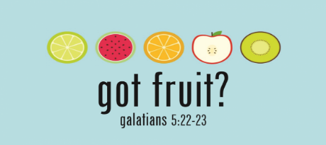

How To Have A Fruitful Summer: KINDNESS
August 2, 2020 Galatians 5:22-23

Greek Word: _____________________ (KREY-ST0-TACE)

Kindness Taste
- An eagerness to put others at ___________
- _________________ temperament to all kinds of people
- A person who ____________________ needs and __________________with helpful actions and words
Cultivating Kindness
____________________

____________________

____________________
Chrestos ____________________

How To Have A Fruitful Summer: KINDNESS
August 2, 2020 Galatians 5:22-23

Greek Word: _____________________ (KREY-ST0-TACE)

Kindness Taste
- An eagerness to put others at ___________
- _________________ temperament to all kinds of people
- A person who ____________________ needs and __________________with helpful actions and words
Cultivating Kindness
____________________

____________________

____________________
Chrestos ____________________

Mark 1:40-42

- ________________ Kinder
- ________________ Kinder
- ________________Kinder

Song Suggestion: Revolutionary Josh Wilson

Missionaries of the Month
Pastor Man & Trang: Vietnam
PRAISE
Man’s Visa to come to US in September was approved.
PRAYER REQUESTS
*Trang, Linda and Sammie's VISA's to be approved. Sammie and Linda's will be harder to get approved due to being single women and no "reason" to go back to Vietnam.
*A lot of uncertainty whether travel to US for Vietnam Day will be allowed but still need to pray, plan, and prepare as if trip is happening.

Connection Card/Prayer Request QR Code CodeQCodeCodeRequest
Mark 1:40-42

- ________________ Kinder
- ________________ Kinder
- ________________Kinder

Song Suggestion: Revolutionary Josh Wilson

Missionaries of the Month
Pastor Man & Trang: Vietnam
PRAISE
Man’s Visa to come to US in September was approved.
PRAYER REQUESTS
*Trang, Linda and Sammie's VISA's to be approved. Sammie and Linda's will be harder to get approved due to being single women and no "reason" to go back to Vietnam.
*A lot of uncertainty whether travel to US for Vietnam Day will be allowed but still need to pray, plan, and prepare as if trip is happening.

Connection Card/Prayer Request QR Code CodeQCodeCodeRequest

