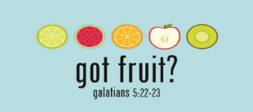

How To Have A Fruitful Summer: PEACE
July 12, 2020 Galatians 5:22-23
Taste
PEACE: _________________: (eh-rey-ney)
- A confident state of ___________________
- _____________________ and ____________________ in difficulties
- The absence of debilitating ____________ and ___________
- Reasonable __________________
- Freedom from ______________ and ___________ thoughts

How to access Biblical Peace
- _________________: Romans 5:1
- _________________: Philippians 4:6-7
- _________ & __________: Isaiah 26:3
- _________________: Psalm 119:165

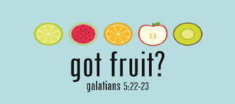

How To Have A Fruitful Summer: PEACE
July 12, 2020 Galatians 5:22-23
Taste
PEACE: ___________________: (eh-rey-ney)
- A confident state of ___________________
- _____________________ and ____________________ in difficulties
- The absence of debilitating ____________ and ___________
- Reasonable __________________
- Freedom from ______________ and ___________ thoughts

How to access Biblical Peace
- _________________: Romans 5:1
- _________________: Philippians 4:6-7
- _________ & __________: Isaiah 26:3
- _________________: Psalm 119:165

PEACE Usages
Upward

- Peace ________ God: Philippians 4:7, Romans 15:13
- Peace about ____________: Psalm 23:4

Outward
- Peace with _______________: Romans 12:18, 14:19

Inward
- Peace with _________________: II Cor. 10:5, Philippians 4:8

Connection Card/Prayer Request QR Code CodeQCodeCodeRequest

PEACE Usages
Upward

- Peace ________ God: Philippians 4:7, Romans 15:13
- Peace about ____________: Psalm 23:4

Outward
- Peace with _______________: Romans 12:18, 14:19

Inward
- Peace with _________________: II Cor. 10:5, Philippians 4:8

Connection Card/Prayer Request QR Code CodeQCodeCodeRequest

