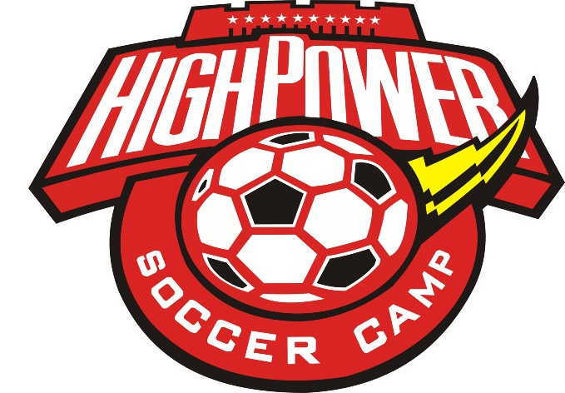
August 5th-9th
6-8:00pm Ages 5-15
Some age groups will be capped in number so register early!
Registration includes instruction, games, snack, backpack, soccer ball, t-shirt, & water bottle!
*Registration Cost: $25 per camper

Hosted by Bible Baptist Church of Sodus
6181 Ridge Rd. 315-483-9886 www.biblebc.org

Registration Options
- Complete form and mail to BBC with check for *amount due payable to BBC with Soccer Camp on Memo line.
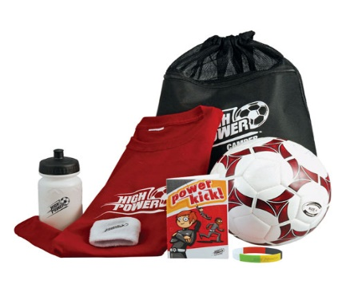
- Complete form and return with payment to BBC during office hours or at one of the walk-in registration times.
- You can register online at www.biblebc.org but payment can only be made by mail, or in person.
Walk-In Registration Times:
Sunday July 14th 1-3pm Wednesday July 17th 6-7pm
Sunday July 21st 9-1-3pm
Each camper must have a completed registration form!

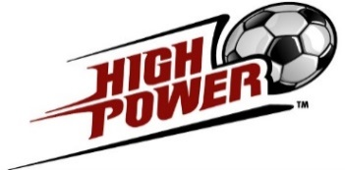
High Power Soccer Camp Registration Form
August 5th-9th 2019 6-8:00pm

Camper Name _____________________________________________________
Age ______ Boy ______ Girl _______
Address ___________________________________________________________
T-Shirt Size: __ (YS) __ (YM) __ (YL) __ (AS) __ (AM) __ (AL) __ (AXL)
Food Allergies: ___________________________________________
Medical Allergies: _________________________________________
Parent/Guardian ____________________________________________________
Phone Number ___________________ Email Address _____________________
Emergency Contact: ______________________ Phone: ___________________
Adults Authorized to Pick-Up Camper: __________________________________
Each camper needs a completed registration form!
Liability Release: I give the camper identified on this form permission to particpate in the High Power Soccer camp to be held at Bible Baptist Church of Sodus (“BBC”) on August 5-9, 2018. FOR MYSELF, SPOUSE, AND CHILD, I KNOWINGLY AND FREELY ASSUME ALL SUCH RISKS, both known and unknown, EVEN IF ARISING FROM THE NEGLIGENCE OF THE RELEASEES or others, and assume full responsibility for my child’s participation.

Emergency Medical Treatment: I understand and agree that BBC does not have medical personnel available at the location of the camp activities. I hereby grant BBC permission to authorize emergency medical treatment, if necessary, and to transport Camper to an appropriate facility to receive emergency medical treatment, and that such action shall be subject to the terms of this Agreement. I understand and agree that BBC assumes no responsibility for any injury or damages which might arise out of, or in connection with, such authorized emergency medical treatment.
Photo/Media Release: I give permission for photographs/videos taken of me/my child/ward while participating in the Soccer Camp to be used in marketing/public relations material in the promotion of Soccer Camp.
I acknowledge that I have read this registration form in its entirety and agree to its stipulations.

Signature: _____________________________________ Date ___________

Printed Name: _________________________________

Please mail completed registration form(s) including *payment due (see cover page) to:
Bible Baptist Church, 6181 Ridge Road, Sodus, NY 14551. Checks should be made payable to BBC with “Soccer Camp” written on the memo line.
Payment Received (Camp Registrar use only) Check _____ Cash ____ Date ____________

